**Natural Calamity Prediction**

**Sudarshan Thakur1, Siddharth Panchal2, Urva Surti3 , Sharvari Patil4**

1,2,3UG Student, Dept. of Computer Engineering, Universal College of Engineering, Mumbai, India

4*Professor, Dept. of Computer Engineering, Universal College of Engineering, Mumbai, India*

---------------------------------------------------------------------***---------------------------------------------------------------------

**Abstract -** *Thousands of human lives are lost every year around the globe, apart from significant damage to our property, animal life etc. due to natural disasters (e.g., earthquake, flood, hurricane and other storms, forest fire etc.). Natural disaster is thing which cannot be prevent, but they can be detected so that it can give people some amount of precious time to get to the safety. In this paper, we are using computer vision and Deep learning to detect natural disaster in image and video stream. We have proposed a system for detection of natural disaster with the help of Convolution Neural Network (CNN), which helps in extracting features of natural disaster more effectively.*

***Key Words*:** Key Words: Disaster prediction, Disaster management, convolution Neural Network, Deep learning

**1.INTRODUCTION** *( Size 11 , cambria font)*

Disaster detection has been one of the most active research areas in remote sensing today because saving human lives is our priority once a disaster occurred. It is crucial in the coordination of fast response actions after a destructive disaster such as landslide and flood. Previous studies have primarily concentrated on detecting changes occurred due to disaster, depending only on sensors, and manually adjust image processing techniques such as image algebra (band differencing and band rationing), post-classification comparison and object-based change detection method in. To increase the accuracy of detection, machine learning is implemented to improve the efficiency of extracting feature. A considerable amount of literature has been published on detection based on machine learning suggested hierarchical shape features in the bags-of-visual words setting to detect large-scale damage. Cyclone track forecasting using artificial neural networks is shown in. In the year 2010, evaluates the effectiveness of multilayer feedforward neural networks, radial basis neural networks, and Random Forests in earthquake damage. Later, in detect damage using 2D and 3D feature of the scene. At the same time, Ying Liu executes deep learning method in geological disaster recognition. One of the most famous practices in deep learning, CNN is making detection getting a better result in a disaster such as an avalanche, earthquake, and landslides..

**2. RELATED WORKS**

Being one among the foremost valuable sources of data for disaster analysis, a growing portion of analysis additionally aims at the detection and classification of natural disaster events in satellite mental imagery. Liu et al. has used deep architecture along with a technique of wavelet transformation based on preprocessing scheme in order to detect disaster affected areas in satellite mental imagery.[1] Wavelet transform is a powerful technique for feature extraction from data that are characterized by frequent additive white noise or other type of noise such as Gaussian or impulsive noise.[1] This technique has been studied in recent years for various applications of intelligent transportation systems, including incident detection, data aggregation, data compression and de-noising. Wavelet transform has many attractive properties, such as multi-resolution analysis, time frequency localization, and multi-rate filtering. Wavelet-based de-noising techniques are well known, especially in the field of image processing. Benjamin et al. [2] approach flood detection in satellite mental imagery as a picture segmentation task wherever a CNN-based framework with 3 different coaching ways has been adopted to get rid of a location bias thanks to native changes in pictures thanks to lighting conditions and different region distortions, the individual elements of the provided satellite mental imagery, i.e., RGB and IR, area unit normalized before coaching the model. In [3], authors exploit the range of various CNNs, that area unit in the main supported expanded convolution and de-convolution [4], during a fusion framework. Initially, binary maps obtained with the individual model’s area unit concatenated, that area unit then accustomed train SVMs for analyzing that and once the individual model is best. Finally, SVMs area unit trained on features/maps obtained with the mix of the most effective models to predict the ultimate binary maps of the check pictures. Ahmad et al. [5] tackle flood detection in satellite mental imagery as a generative downside wherever Associate in Nursing Adversarial Generative Networks (GANs) primarily based framework has been planned. The framework in the main depends on a GANs design, particularly V-GAN [6], originally developed for the retinal vessel segmentation to adopt the design for the flood detection task, the highest layer of the generative network is extended with a threshold mechanism to come up with binary segmentation mask of the flooded regions in satellite mental imagery. In another work from identical authors [7], the input layer is changed to support four-channel input pictures (i.e., RGB and IR) and several other experiments area unit conducted to judge the performance of RGB and IR elements separately and together. In, totally different indices, particularly Land Water Index (LWI), Normalized distinction Vegetation Index (NDVI) and Normalized distinction Water Index (NDWI) area unit chosen from the spectral pictures. later on, 2 different ways supported supervised classification and un-supervised bunch techniques area unit then adopted for the identification of flooded regions in satellite mental imagery.

**3. METHODOLOGY**

Deep learning (DL) algorithms, which learn the characteristic features in a hierarchical manner where neural network is one type of machine learning. This neural network is an algorithm modeling nerve cells (neurons) of the brain of the living organism and has a long history of research starting from 1940, and Hubel and Wiesel publish a paper on cat's visual cortex in 1968 are examples of neural inspired models[8].

**3.1. Overview**

CNN is a sequence of layers, and each layer of CNN transforms one volume of activations to another through differentiable function. CNN consists of 3 primary hidden layers: convolution layer, pooling layer, as well as a fully connected layer; which its neuron is arranged in 3 dimensions (width, height, depth). Each layer will be further explained in the next sub-section: convolution layer (III.B), pooling layer (III.C) and fully-connected layer (III.D). CNN is getting more attention attributed to its outstanding performance in solving various problems. Facebook is one of the examples, whose company is implementing CNN for tagged face detection. Google too utilizes it for photo searching and speech recognition [9]. Besides, application of CNN in Spotify and LINE Company are widely recommended in most of the projects.

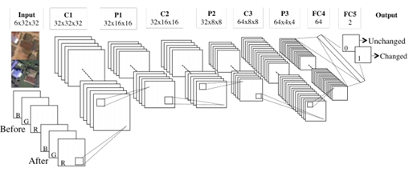

**Figure – 1**: Architecture of Convolution Neural Network

**3.2. Convolution Layer (CL)**

A CL consists of filters and convolves them on an input image to extract features. CL (refer Fig.2) [9] is the set of neighboring nodes in the lower layer connecting with nodes of upper layer and edges. The calculation of CL's node involves node value and edge weight and activation function. Besides, the set of neighboring nodes are also known as the local node. CL is commonly used in image processing with a neural network. Calculation of image through convolution layer has the same effect as applying an image filter. Meanwhile, the characteristics of the filter are determined by the weight of the edge. A filter can emphasize features in an image and pass it to the upper layer. In other words, convolution layer performs feature extraction from images.

**3.3. Pooling layer (PL)**

A PL provides subsampling to the output of the lower layer to achieve translational invariance. PL has a local connection with the other layer, which is similar to CL (refer Fig.3) [9]. However, the method of calculating the value of the node is different from the fully-connected layer and convolution layer. The value determined from the local node in the lower layer is bringing forward to be upper layer's value. For example, the maximum value of the local node is made to be upper layer's value. PL is also commonly used in image processing with a neural network. Calculation of image through PL does not affect the value especially during small changes (translational invariance) because the only maximum value is taken in particular area and bring to the upper layer. Hence, pooling layer returns the same value even with small changes within the range. In other words [9], also if the image changes slightly, it will still yield the same result.

**3.4. Fully-Connected Layer (FCL)**

Each neuron in this layer is connected to all the numbers in the lower volume. Based on the CIFAR-10 example in [10], FCL will compute the class scores and produce an outcome of [1x1x10], where each of the ten numbers resembles class score. Meanwhile, in our proposed method, all neurons from FC4 are connected and form 2 score: change (disaster occurred) or unchanged (disaster do not occur).

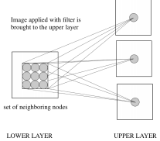

**Figure – 2**: Convolution layer

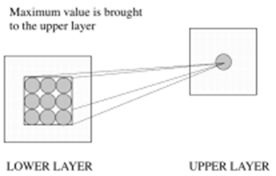

**Figure – 3**: Poling layer

**4. PROPOSED SYSTEM**

Recently many researchers [9], have implemented machine learning method in detecting or recognizing disaster region to increase the accuracy of the result to manifest the potential of this approach and its appropriateness for this application, one of the branch technologies in machine learning (deep learning); we implement CNN as essential techniques to detect the changed area or known as the occurrence of a disaster.

Our proposed system consists of two phases: training phase and testing phase. We use the changes of pre-disaster (RGB, three channel) and post-disaster (RGB, three channel) as input training patches (RGB, six channel), aligned top bottom (refer Fig 1) [9]. This part shows the originality of our research, which gives high accuracy to the result. The original point of our research is learning disaster changes from the early phase. In other words, the differences obtained from pre-disaster imagery (RGB, three channel) and post-disaster imagery (RGB, three channel) are learned as image feature of change detection. In most of the prior studies, the only feature of disaster from post-disaster is absorbed as the feature of disaster, then when query imagery fulfills the character of disaster, it will be considered as change

detection. Hence, previous studies might have consequences of obtaining error from the early stage. Our research focuses on change detection from pre-disaster imagery and post-disaster imagery, which reduces error from the initial stage (learning stage). Also, changes occurred means disaster occurred. Most importantly, our method is faster in disaster detection compared to the previous study

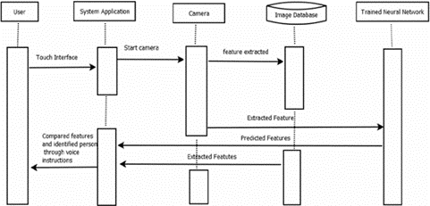

**Figure – 4**: Sequence diagram of our proposed system

**4.1. Data**

We have a data-set which consists of images which shows the region of interest before and after the disaster has hit. Our data set is collection of Google images belonging to four separate classes, which sums up to total of 4428. [11]

* + - 1. *Cyclone/Hurricane: 928 images*
      2. *Earthquake: 1,350*
      3. *Flood: 1,073*
      4. *Wildfire: 1,077*

These data- sets are trained using CNN to recognize each of the natural disaster.

**4.1. Training Data**

Training phase concentrate on learning all possible features and characteristic of geographical changes or known as disastrous area especially for landslide and flood by applying CNN as a leading technology for disaster detection in this phase. First, training patches were created by trimming pre-disaster, post-disaster and ground truth images of each particular disaster scene from 1072x927 pixels image into 32x32 pixels. Training phase concentrate on learning all possible features and characteristic of geographical changes or known as disastrous area especially for landslide and flood by applying CNN as a leading technology for disaster detection in this phase [9]. First, training patches were created by trimming pre-disaster, post-disaster and ground truth images of each particular disaster scene from 1072x927 pixels image into 32x32 pixels.

**4.1. Testing Data**

In the testing phase, RGB channels of pre-disaster and post disaster (6 channels) are first are merged into one image. Then, the raster scan is applied to this image by sliding over 16 pixels to obtain best predictions value of disaster occurrence. Based on the knowledge acquired in preceding training phase, only the highest predictions value with label "1" will be extracted, and 32x32 pixel sized rectangle will be drawn [9]. The drawn region mention here refers to the disaster region.

**5. IMPLEMENTATION**

The System Development Life Cycle is that the method of developing data systems through investigation, analysis, design, implementation, and maintenance. The System Development Life Cycle (SDLC) is additionally called data Systems Development or Application Development.

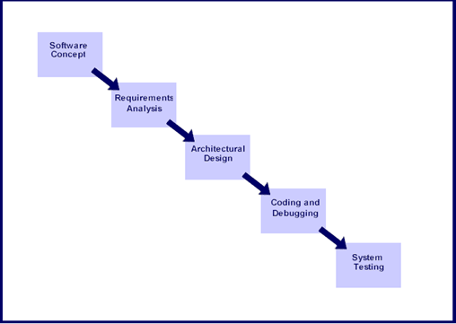

**Figure – 5**: System Development life cycle

**5.1. Software Concept**

The first step is to spot a requirement for the new system. This can embrace determinative whether or not a business downside or chance exists, conducting a practicability study to see if the projected answer is price effective, and developing a project set up.

This method could involve finishing end users come back with a thought for rising their work. Ideally, the method happens in cycle with a review of the organization's strategic conception to make sure that it's being employed to assist the organization income through its strategic objectives. Management might have to approve thought ideas before any cash is budgeted for its development.

**5.2. Requirement Analysis**

Requirement’s analysis is that the method of analyzing the knowledge desires of the tip users, the structure setting, and any system presently being employed, developing the useful needs of a system which will meet the wants of the users. Also, the wants ought to be recorded in a very document, email, computer programmer storyboard, executable prototype, or another type. The necessary documentation ought to be noted throughout the remainder of the system development method to confirm the developing project aligns with user desires and requirements.

Professionals should involve finishing users during this method to confirm that the new system can perform adequately and meets their desires and expectations.

**5.3. Architectural Design**

After the wants are determined, the mandatory specifications for the hardware, software, people, and information resources, and therefore the data merchandise which will satisfy the user needs of the projected system will be determined. the planning can function as a blueprint for the system and helps notice issues before these errors or issues area unit designed into the ultimate system Professionals produce the system style, however should review their work with the users to confirm the planning meets users' desires.

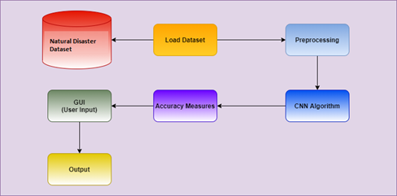

**Figure – 6**: System Architecture

**5.4. Test System**

The system should be tested to gauge its actual practicality in reference to expected or meant practicality. Another problem to contemplate throughout this stage would be changing previous information into the new system and coaching workers to use the new system to consider during this stage would be converting old data into the new system and training employees to use the new system [12]. Users are going to be key in determining whether or not the developed system meets the meant needs, and therefore the extent to that the system is really used.

**5.5. Maintenance**

Inevitably the system can like maintenance. Proposed system will certainly endure modification once it's delivered to the client. There are several reasons for the modification. Modification may happen because of some surprising input values into the system, which was unexpected. Additionally, the changes within the system may directly have an effect on the computer code operations. The application ought to be developed to accommodate changes that would happen throughout the post-implementation amount. during the post implementation period.

There are various software process models like: -

Prototyping Model

a) RAD Mode

b) The Spiral Model

c) The Waterfall Model

d) The Iterative Model

Of all these process models we’ve used the Iterative model (The Linear Sequential Model) for the development of our project.

**6. FUTURE SCOPE AND CONCLUSIONS**

Our application aims to solve all the queries related to the natural calamities. The main advantage of the proposed system is to warn the users from the natural calamity. It is more accurate, complexity is reduced, processing time is minimized. To increasing the accuracy of natural disaster detectors, we can augment existing sensors, which, allow people to take precautions, stay safe, and prevent/reduce the number of deaths and injuries that happen due to these disasters. It can be even used with different social media platform for analysis of disaster-related visual content, which have been captured by the user and shared via social media platforms recently, so that we can make people aware about the disaster as soon as possible As per our studies we found out that convolution neural networks perform best in large scale video classification. CNN architecture is really very powerful in learning features from weakly-labelled data that far surpass feature-based methods in performance and that these benefits are surprisingly robust to details of the connectivity of the architectures in time [13]. We tend to chiefly rely on deep features extracted through totally different pre-trained deep models singly and conjointly through fusion. We tend to determine higher results for the models pre-trained on Place’s dataset compared to those pre-trained on objects dataset, showing the importance of the scene-level data within the task. We tend to conjointly determine that the object-level data well enhances the scene-level features once conjointly used. Among the fusion strategies, double fusion combines the capabilities of each early and late fusions and ultimately results in higher results. Considering the advance with fusion techniques, in future, we tend to aim to use some optimization strategies to assign a lot of specific weights to the individual models. Within the satellite sub-task, we tend to found that simply a standard image segmentation approach is of no facilitate and that we enforced a task-oriented CNN and transfer learning-based approach.

**REFERENCES**

1. Y. Liu and L. Wu. Geological disaster recognition on optical remote sensing images using deep learning. Procedia Computer Science, 91:566–575, 2016.
2. B. Bischke, P. Bhardwaj, A. Gautam, P. Helber, D. Borth, and A. Dengel. Detection of flooding events in social multimedia and satellite imagery using deep neural networks. In Proceedings of the Working Notes Proceeding MediaEval Workshop, Dublin, Ireland, pages 13–15, 2017.
3. K. Nogueira, S. G. Fadel, ´I. C. Dourado, R. d. O. Werneck, J. A. Munoz, O. A. Penatti, R. T. Calumby, L. T. Li, J. A. ˜ dos Santos, and R. d. S. Torres. Exploiting convnet diversity for flooding identification. IEEE Geoscience and Remote Sensing Letters, 15(9):1446–1450, 2018.
4. F. Yu and V. Koltun. Multi-scale context aggregation by dilated convolutions. arXiv preprint arXiv:1511.07122, 2015.
5. K. Ahmad, K. Pogorelov, M. Riegler, N. Conci, and H. Pal. Cnn and gan based satellite and social media data fusion for disaster detection. In Proc. of the MediaEval 2017 Workshop, Dublin, Ireland, 2017.
6. J. Son, S. J. Park, and K.-H. Jung. Retinal vessel segmentation in fundoscopic images with generative adversarial networks. arXiv preprint arXiv:1706.09318, 2017.
7. K. Ahmad, K. Pogorelov, M. Riegler, N. Conci, and P. Halvorsen. Social media and satellites. Multimedia Tools and Applications, pages 1–39, 2018..
8. T. Hubel, D. and Wiesel, “Receptive fields and functionalarchitecture of monkey striate cortex,” J. Physiol., no. 195, pp. 215–243, 1968.
9. Siti Nor Khuzaimah Binti Amit and Yoshimitsu Aoki. Disaster Detection from Aerial Imagery with Convolutional Neural Network, September 2017, 2017 International Electronics Symposium on Knowledge Creation and Intelligent Computing (IES-KCIC)
10. A. Krizhevsky, I. Sutskever, and G. E. Hinton, “ImageNet Classification with Deep Convolutional Neural Networks,” Proc. The Int. Conf. Neural Inf. Process. Syst., pp. 1097–1105, 2012.
11. Adrian Rosebrock. Detecting Natural Disasters with Keras and Deep Learning November 11, 2019
12. Prof. Jannelle "Systems Analysis and Online Grading." Graduateway, 22 Jul 2016.
13. H. Wang, A. Klaser, C. Schmid, and C.-L. Liu. Action recognition by dense trajectories. In CVPR. IEEE, 2011. 2, 8.